Terms of Website Use
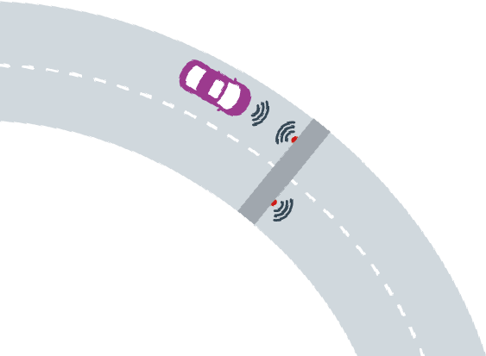

General
1.1. This website is operated by Turas Mobility Service Ireland Limited (“Turas Ireland”) on behalf of Transport Infrastructure Ireland (“TII”). Your use of our website (which includes visiting) is subject to these terms of use. Please read these terms of use carefully before you use our website, as by doing so you are deemed to have accepted these terms of use in full. If you do not agree with these terms of use, please do not use our website.
1.2. We may revise these terms of use, from time to time by amending this page. Please check this page regularly to take notice of any changes we make, as, by continuing to use our website, you will be deemed to have accepted such changes.
1.3. These terms of use shall be governed by the laws of Ireland. The courts of Ireland shall have exclusive jurisdiction over any claims or disputes arising in relation to, out of, or in connection with these terms of use.

Intellectual property (Including copyright)
We own or are licensed to use all intellectual property rights (including all copyrights, patents, trademarks, trade secrets, rights in confidential information and design rights whether registered or unregistered) which subsist in the eFlow website, its contents and underlying software. You may make an electronically stored transient copy of the eFlow website or extracts or portions thereof, for the purposes of viewing them online only but otherwise, unless expressly authorised by us to do so, you may not change, copy, store, publish, rent, licence, sell or distribute in any way any of the eFlow website, its contents or its underlying software.

Information
The materials and information provided on our website are provided solely for information purposes only. Whilst all reasonable efforts are made to ensure that any information contained on the website is correct, we give no representations or warranties, express or implied in relation to the accuracy or completeness of said information.

Services
We may, at our discretion, provide you with services including an Account and news and information services. You agree to comply with the terms and conditions on which any such services will be provided to you as set out in these terms of use and elsewhere on the eFlow website.

Website Access
We will use reasonable endeavours to ensure that this website is fully operational at all times. However, due to the nature of interactive services and the internet generally, we cannot guarantee that the website will be free from delays, interruptions or errors, and access to the eFlow website may be suspended (whether by us or due to external causes) temporarily and/or without notice. We will not be liable for any loss or damage arising from the eFlow website not being available (whether for internal processing reasons or otherwise).

Disclaimer
Except as expressly set out in these terms and conditions, all representations, warranties, terms and conditions whether express or implied in relation to this website or the information contained therein, are hereby excluded to the fullest extent permitted by law.

Limitation of Liability
Due to the fact that we cannot guarantee that our website will be fault-free or that the information contained on the website will be correct, we do not accept any liability for any damage or loss suffered by you (whether direct, indirect, special, incidental, punitive or consequential loss, including loss of profits) arising as a result of the website or the information contained therein (including any errors, inaccuracies or omissions in such information or any faults, interruptions or delays in connection with the website).

Links to other websites
We may provide links to websites on the internet which are operated by third parties. Such links are provided for your convenience only. We make no representations whatsoever about any other websites which you may access through our website or which may link to our website. When you access any third-party website or application, you understand that it is independent from us and that we have no control over the content or availability or privacy practices of that website or application.

Indemnity
You agree to indemnify us and hold us harmless from and against any claims, actions or demands (including any legal fees incurred in connection therewith) resulting from your misuse of the eFlow website or its services or your breach of these terms of use.

Links to this website
We have not reviewed any or all of the third-party websites or applications which contain links to our website and we are not responsible for the content of any such websites or applications. If you wish to link your website or application to our website, you must obtain our prior written consent before doing so. We reserve the right to withdraw your permission to link to our website without notice at any time. Except as expressly set out in clause 2.1, you may not use or quote in any way (including, but not limited to, changing, copying, storing, publishing, renting, licensing, selling, distributing), any extracts or portions of our website in third-party websites or applications or otherwise, unless expressly authorised by us to do so.

Registration and Security
11.1. In order to use certain parts of our website, you are required to register with us. The details you provide on registration are important and must be true and accurate. If there are any changes to these details, please record them by logging in to your online account and editing your information.
11.2. If you choose, or you are provided with a password, or any other piece of information as part of our security procedures, you must treat such information as confidential and you must not disclose it to any third party. You agree to notify us immediately if your password is lost or misused. Subject to appropriate security checks, you will be issued with a new password.

Privacy Statement

Any personal data collected on our website will be processed in accordance with our privacy statement which is posted on our website. Please read this privacy statement carefully, as, by using our website, you consent to such processing.

Consequences

If we become aware that you have violated any of the terms and conditions contained in this document we may immediately take corrective action including preventing you from accessing and/or using the services offered by eFlow and removing any information, data and content on the eFlow website by you, at any moment and without notice. If we have been injured by your violation we may in our discretion seek to recover damages or other forms of monetary compensation from you.

www.eflow.ie @eflow_freeflow.
Eflow, Po Box 13294, South City DSU, Cork.

